**SCREEN SHOTS**

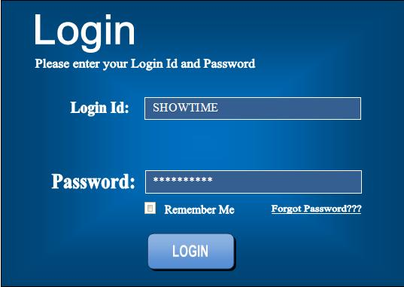

**Screen 1: Login Screen**

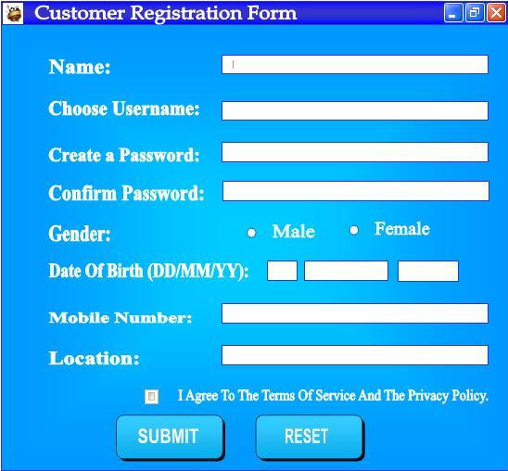

**Screen 2: Customer Registration Form**

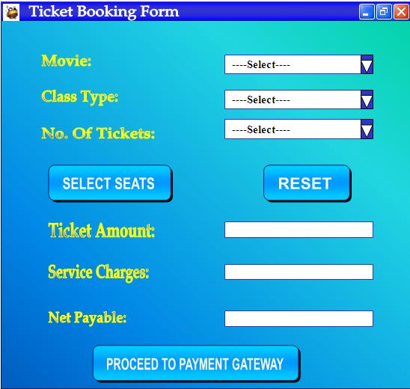

**Screen 3: Ticket Booking Form**

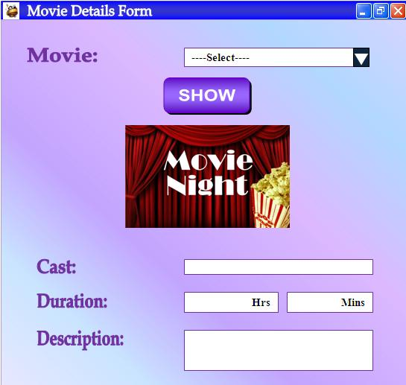

**Screen 4: Movie Details Form**

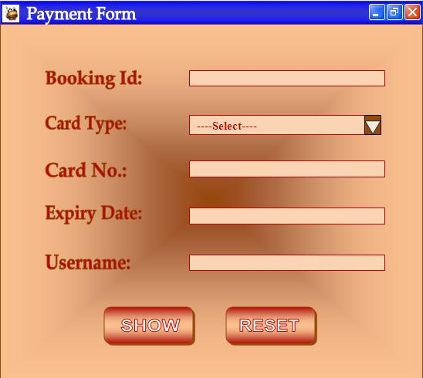

**Screen 5: Payment Form**